Факультет Математики и Информатики  
Департамент Информатики

**Лабораторная работа №1**

По курсу “Принципы тестирования”

Тема:”Test Cases.”

Выполнил студент группы I1902:  
Чобану Артём

Кишинэу, 2020

**Задание:**

**LAB – Test cases task: Cover the following requirements with test cases (make sure you cover all necessary combinations) for airport.md web site.**

1. Homepage should provide the ability to Search any information on the web-site.
2. CURRENCY CONVERTER should be always present on DISCOVER section, and it should convert the following currencies for the user: MDL, EUR, USD, RUB, RON, UAH. Converter data should correspond [Official exchange rates](https://www.bnm.md/en/content/official-exchange-rates) (bnm.md).
3. Home page should display the flight schedule for 8 last Arrivals and Departures.

**Defects**

**Defect No.1**

**Summary:** Currency converter doesn’t accept the dot (“.”) character if language is set to Russian.

**Description:** The user is unable to enter a floating-point number into the currency converter because it is impossible to enter the dot (“.”) character, but only if the language is set to Russian. It works with English, though.

**Platform:** Windows 10, Google Chrome

**Steps to reproduce:**

1. Open the “airport.md” website
2. Scroll down to the currency converter
3. Select any text field from the currency converter
4. Enter an integer number
5. Set language to Russian
6. Try to enter the “.” Or “,” characters

**Actual result:** The character is not entered, nothing has changed.

**Expected result:** The character should be added to the text field.

**Severity:** Low

**Priority:** Low

**Defect No.2**

**Summary:** Impossible to scroll after changing the width while the menu is opened

**Description:** If a window width is increased while menu is opened (in mobile version), then it is impossible to scroll vertically.

**Platform:** Windows 10, Google Chrome

**Steps to reproduce:**

1. Open the “airport.md” website.
2. Reduce the screen width until the mobile mode is enabled.
3. Open the menu.
4. Increase the screen width (Maximizing the browser window will have the same effect).
5. Scrolling is impossible.

**Actual result:** The website has returned to the desktop version, but vertical scroll is still disabled.

**Expected result:** The website should return to the desktop version and fully working.

**Severity:** Low

**Priority:** Low

**Screenshots:**

**Test case 1:**

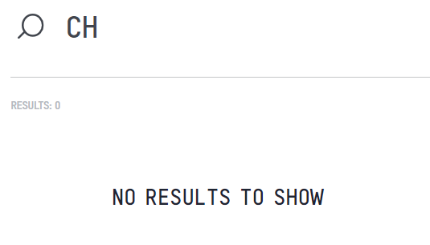

**Test case 2:**

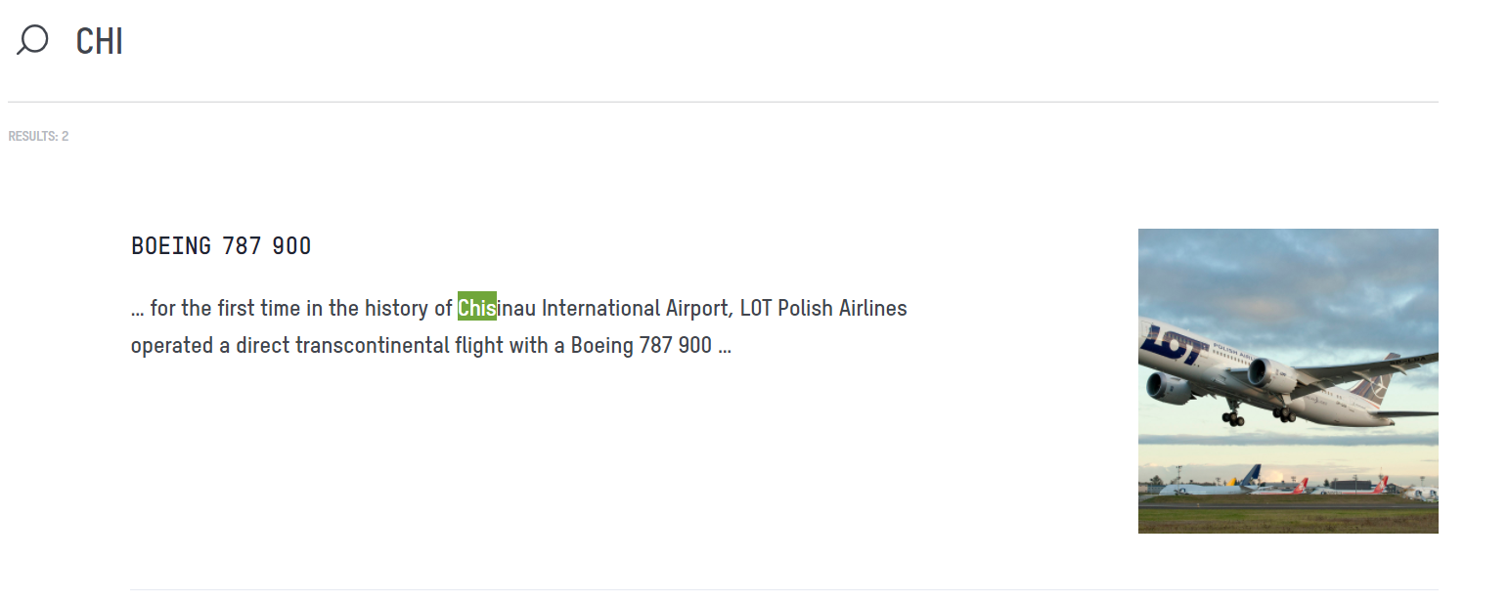

**Test case 3:**

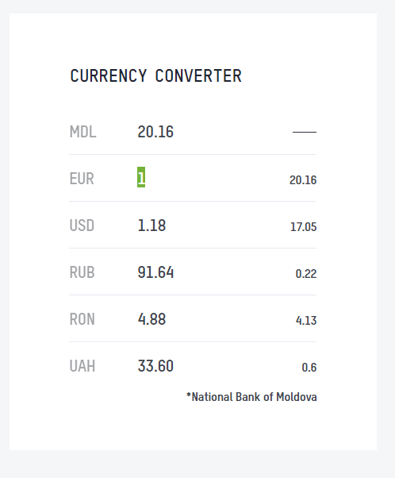

**Test case 4:**

